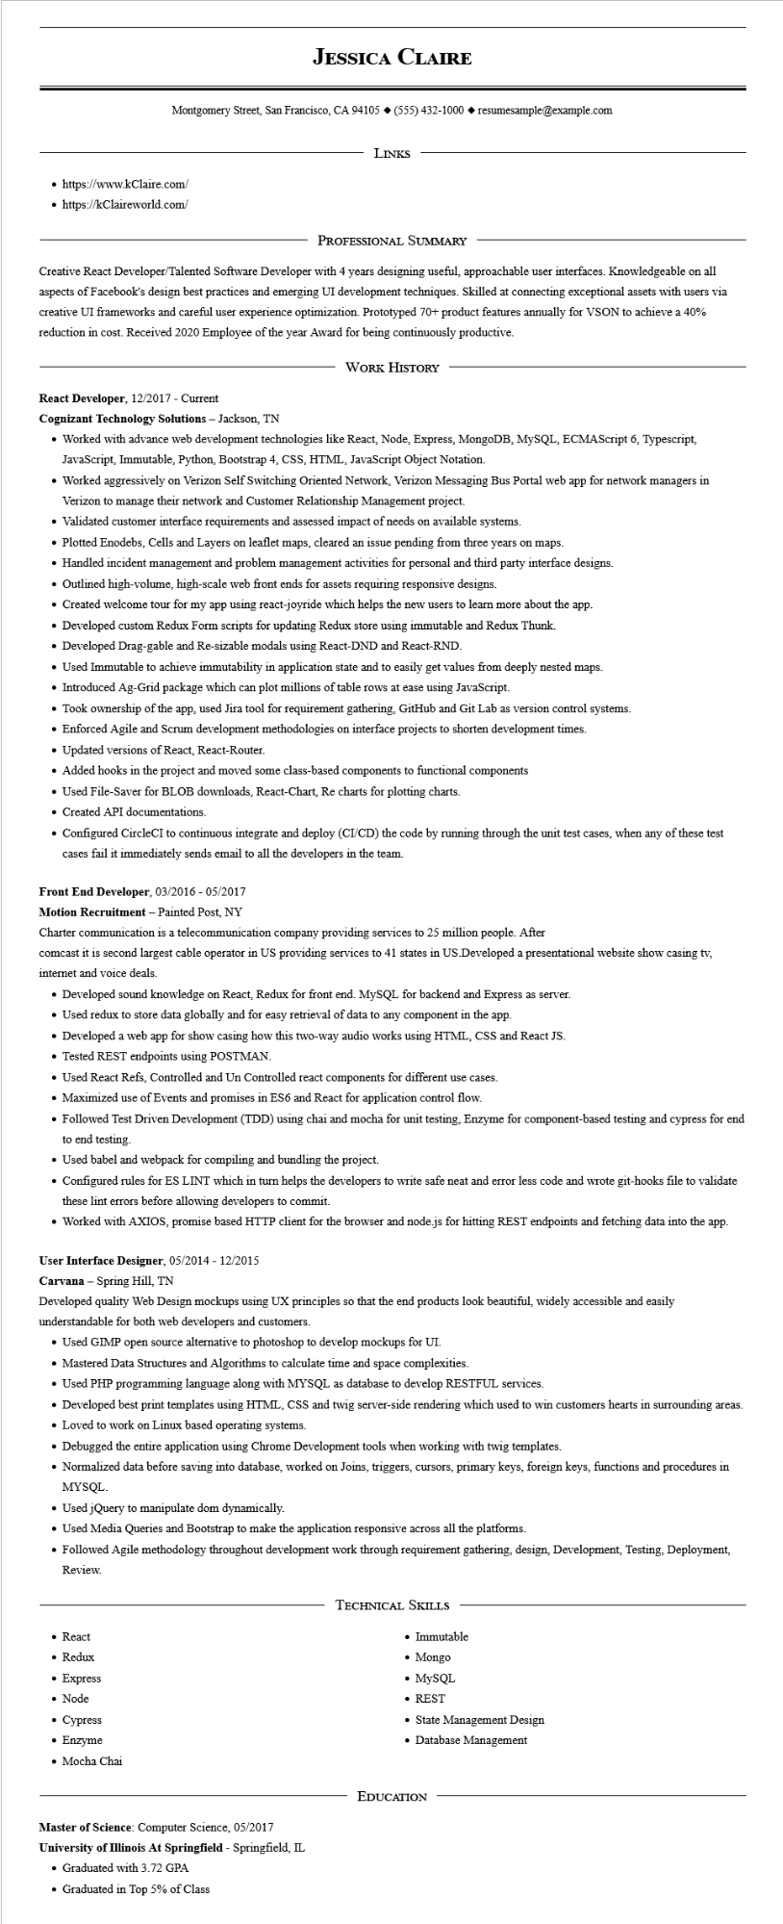
JESSICA CLAIRE
Montgomery Street, San Francisco, CA 94105 ◆ (555) 432-1000 resumesample@example.com
• https://www.kClaire.com/
• https://kClaireworld.com/
LINKS
PROFESSIONAL SUMMARY
Creative React Developer/Talented Software Developer with 4 years designing useful, approachable user interfaces. Knowledgeable on all aspects of Facebook's design best practices and emerging UI development techniques. Skilled at connecting exceptional assets with users via creative UI frameworks and careful user experience optimization. Prototyped 70+ product features annually for VSON to achieve a 40% reduction in cost. Received 2020 Employee of the year Award for being continuously productive.
WORK HISTORY
React Developer, 12/2017 - Current
Cognizant Technology Solutions - Jackson, TN
• Worked with advance web development technologies like React, Node, Express, MongoDB, MySQL, ECMAScript 6, Typescript, JavaScript, Immutable, Python, Bootstrap 4, CSS, HTML, JavaScript Object Notation.
• Worked aggressively on Verizon Self Switching Oriented Network, Verizon Messaging Bus Portal web app for network managers in Verizon to manage their network and Customer Relationship Management project.
• Validated customer interface requirements and assessed impact of needs on available systems.
• Plotted Enodebs, Cells and Layers on leaflet maps, cleared an issue pending from three years on maps.
• Handled incident management and problem management activities for personal and third party interface designs.
• Outlined high-volume, high-scale web front ends for assets requiring responsive designs.
• Created welcome tour for my app using react-joyride which helps the new users to learn more about the app.
• Developed custom Redux Form scripts for updating Redux store using immutable and Redux Thunk.
• Developed Drag-gable and Re-sizable modals using React-DND and React-RND.
• Used Immutable to achieve immutability in application state and to easily get values from deeply nested maps.
• Introduced Ag-Grid package which can plot millions of table rows at ease using JavaScript.
• Took ownership of the app, used Jira tool for requirement gathering, GitHub and Git Lab as version control systems.
• Enforced Agile and Scrum development methodologies on interface projects to shorten development times.
• Updated versions of React, React-Router.
• Added hooks in the project and moved some class-based components to functional components
• Used File-Saver for BLOB downloads, React-Chart, Re charts for plotting charts.
• Created API documentations.
• Configured CircleCI to continuous integrate and deploy (CI/CD) the code by running through the unit test cases, when any of these test cases fail it immediately sends email to all the developers in the team.
Front End Developer, 03/2016 - 05/2017
Motion Recruitment - Painted Post, NY
Charter communication is a telecommunication company providing services to 25 million people. After
comcast it is second largest cable operator in US providing services to 41 states in US.Developed a presentational website show casing tv, internet and voice deals.
• Developed sound knowledge on React, Redux for front end. MySQL for backend and Express as server.
• Used redux to store data globally and for easy retrieval of data to any component in the app.
• Developed a web app for show casing how this two-way audio works using HTML, CSS and React JS.
• Tested REST endpoints using POSTMAN.
• Used React Refs, Controlled and Un Controlled react components for different use cases.
• Maximized use of Events and promises in ES6 and React for application control flow.
• Followed Test Driven Development (TDD) using chai and mocha for unit testing, Enzyme for component-based testing and cypress for end to end testing.
• Used babel and webpack for compiling and bundling the project.
• Configured rules for ES LINT which in turn helps the developers to write safe neat and error less code and wrote git-hooks file to validate these lint errors before allowing developers to commit.
• Worked with AXIOS, promise based HTTP client for the browser and node.js for hitting REST endpoints and fetching data into the app.
User Interface Designer, 05/2014 - 12/2015
Carvana - Spring Hill, TN
Developed quality Web Design mockups using UX principles so that the end products look beautiful, widely accessible and easily
understandable for both web developers and customers.
• Used GIMP open source alternative to photoshop to develop mockups for UI.
• Mastered Data Structures and Algorithms to calculate time and space complexities.
• Used PHP programming language along with MYSQL as database to develop RESTFUL services.
• Developed best print templates using HTML, CSS and twig server-side rendering which used to win customers hearts in surrounding areas.
• Loved to work on Linux based operating systems.
• Debugged the entire application using Chrome Development tools when working with twig templates.
• Normalized data before saving into database, worked on Joins, triggers, cursors, primary keys, foreign keys, functions and procedures in MYSQL.
• Used jQuery to manipulate dom dynamically.
• Used Media Queries and Bootstrap to make the application responsive across all the platforms.
• Followed Agile methodology throughout development work through requirement gathering, design, Development, Testing, Deployment, Review.
• React
• Redux
• Express
• Node
• Cypress
• Enzyme
• Mocha Chai
Master of Science: Computer Science, 05/2017 University of Illinois At Springfield - Springfield, IL
• Graduated with 3.72 GPA
• Graduated in Top 5% of Class
TECHNICAL SKILLS
• Immutable
• Mongo
• MySQL
• REST
• State Management Design
• Database Management
EDUCATION

